Excitation Table



**3 BIT UP COUNTER using t flip-flops**

Depending on last number we get to know how many flip flops are required here since it is a 3 bit last number is 111

Step 1: 000,001,010,011,100,101,110,111,000…..

(Explanation: if PS(PREVIOUS Output or Present State)=000 then NS=001,

Similarly PS(PREVIOUS Output or Present State)=001 then NS=010,

Similarly PS(PREVIOUS Output or Present State)=010 then NS=011,

Similarly PS(PREVIOUS Output or Present State)=011 then NS=100,

Similarly PS(PREVIOUS Output or Present State)=100 then NS=101,

Similarly PS(PREVIOUS Output or Present State)=101 then NS=110,

Similarly PS(PREVIOUS Output or Present State)=110 then NS=111,

Similarly PS(PREVIOUS Output or Present State)=111 then NS=000)

Step 2: Create Functional table

|  |  |  |
| --- | --- | --- |
| PS  QC QB QA | NS  QC+ QB+ QA+ | TC TB TA |
| 000 | 001 |  |
| 001 | 010 |  |
| 010 | 011 |  |
| 011 | 100 |  |
| 100 | 101 |  |
| 101 | 110 |  |
| 110 | 111 |  |
| 111 | 000 |  |

Step 3:

Use excitation table

|  |  |  |
| --- | --- | --- |
| PS  QC QB QA | NS  QC+ QB+ QA+ | TC TB TA |
| 000 | 001 | 0 |
| 001 | 010 | 0 |
| 010 | 011 | 0 |
| 011 | 100 | 1 |
| 100 | 101 | 0 |
| 101 | 110 | 0 |
| 110 | 111 | 0 |
| 111 | 000 | 1 |

Here compare PS OF QC AND NS OF QC+ WRITE tc excitation table

Ex:if QC=0 QC+=0 THEN TC=0

Similarly compare PS(QB) AND NS(QB+) WRITE TB

Similarly compare PS(QC) AND NS(QC+) WRITE TA

THEN

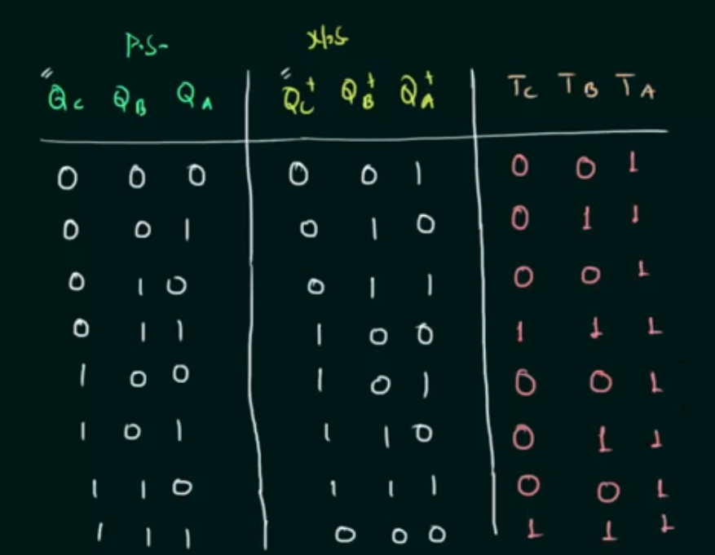

Step 4:After that get BOOLEAN EXPRESSIONS FOR TC,TB,TA

TC=∑m(3,7) IF YOU OBSERVE TC=1 for PS=011,111 WRITE THOSE NOS

(IF THEY HAVE DON’T CARES ALSO THAT HAS TO BE WRITTEN SEPEARTELY)

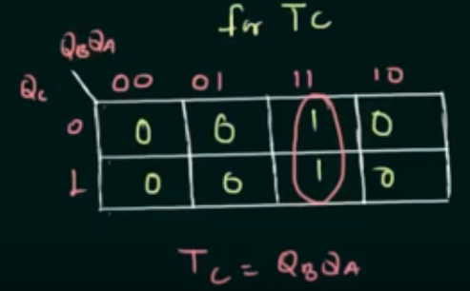

TB=∑m(1,3,5,7) IF YOU OBSERVE TB=1 WHEN PS=001,011,101,111

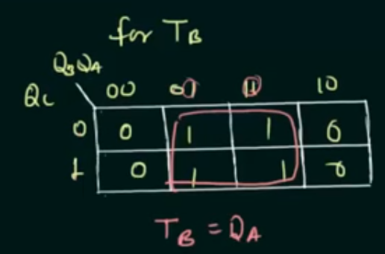

TA=∑m(0,1,2,3,4,5,6,7)

TA=1 AS ALL OF THEM WILL BE MAPPED.

STEP 5:DRAW THE LOGIC DIAGRAM

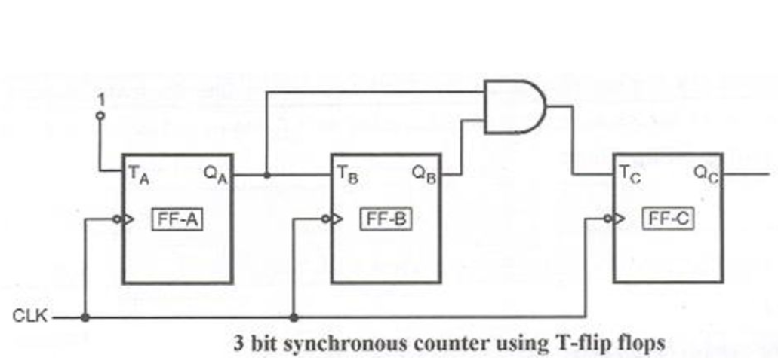

References

See this video if you have doubts

https://www.youtube.com/watch?v=6e8oV2blkGs

M0D-10 COUNTER

HERE THE LAST NO IS 9 WHICH IS A FOUR BIT 1001

Step 1:0000,0001,0010,0011,0100,0101,0110,0111,1000,1001,0000,..

(Explanation: if PS(PREVIOUS Output or Present State)=0000 then NS=0001,

Similarly PS(PREVIOUS Output or Present State)=0001 then NS=0010,

Similarly PS(PREVIOUS Output or Present State)=0010 then NS=0011,

Similarly PS(PREVIOUS Output or Present State)=0011 then NS=0100,

Similarly PS(PREVIOUS Output or Present State)=0100 then NS=0101,

Similarly PS(PREVIOUS Output or Present State)=0101 then NS=0110,

Similarly PS(PREVIOUS Output or Present State)=0110 then NS=0111,

Similarly PS(PREVIOUS Output or Present State)=0111 then NS=1000

Similarly PS(PREVIOUS Output or Present State)=1000 then NS=1001

Similarly PS(PREVIOUS Output or Present State)=1001 then NS=0000)

Step 2:

|  |  |  |
| --- | --- | --- |
| PS  Q4 Q3 Q2 Q1 | NS  Q4+Q3+Q2+Q1+ | J4K4J3K3J2K2J1K1 |
| 0000 | 0001 |  |
| 0001 | 0010 |  |
| 0010 | 0011 |  |
| 0011 | 0100 |  |
| 0100 | 0101 |  |
| 0101 | 0110 |  |
| 0110 | 0111 |  |
| 0111 | 1000 |  |
| 1000 | 1001 |  |
| 1001 | 0000 |  |

Step 3:

Write excitation table

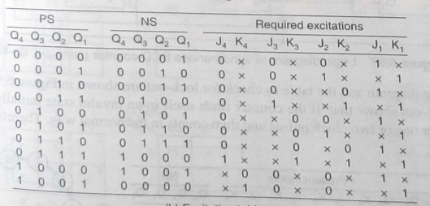

Step4: get logical expressions, here 1010,1011,1100,1101,111 are not present in the table so write don’t cares for them

Using k-maps get expressions J4,K4,J3,K3,J2,K2,J1,K1

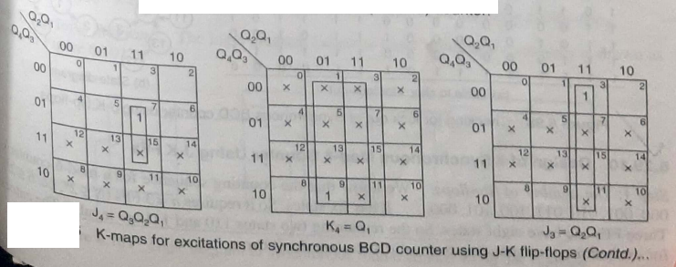

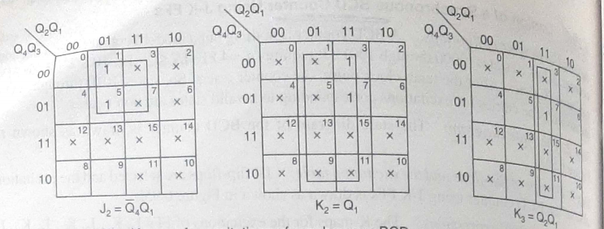

J1=1,K1=1

STEP 5 LOGICAL DIAGRAM:

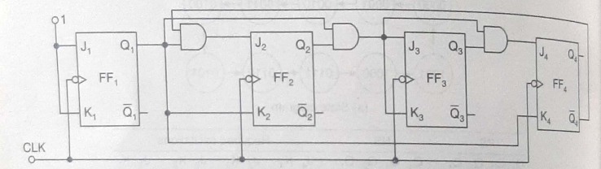

IF YOU STILL HAVE DOUBTS YOU CAN MAIL ME